PYTHON PROJECTS
OUTPUT SCREENSHOTS & SAMPLE RUNS
A collection of 10 Python programs
with example inputs and console outputs
Prepared from the uploaded project files

About this document
This document presents a sample console run for each of the 10 uploaded Python projects. The outputs were generated by running the supplied .py files with example inputs. These are terminal-output captures rendered as images for easy inclusion in a project report. The sample inputs are demonstrations and can be changed when you run the programs.
Note: If a program contains a syntax or runtime error, its actual result is recorded rather than silently correcting the source.

Project 1: Electricity Billing
Source file: project-1(1).py
Execution status: Return code 0. Any error text is shown in the output image.
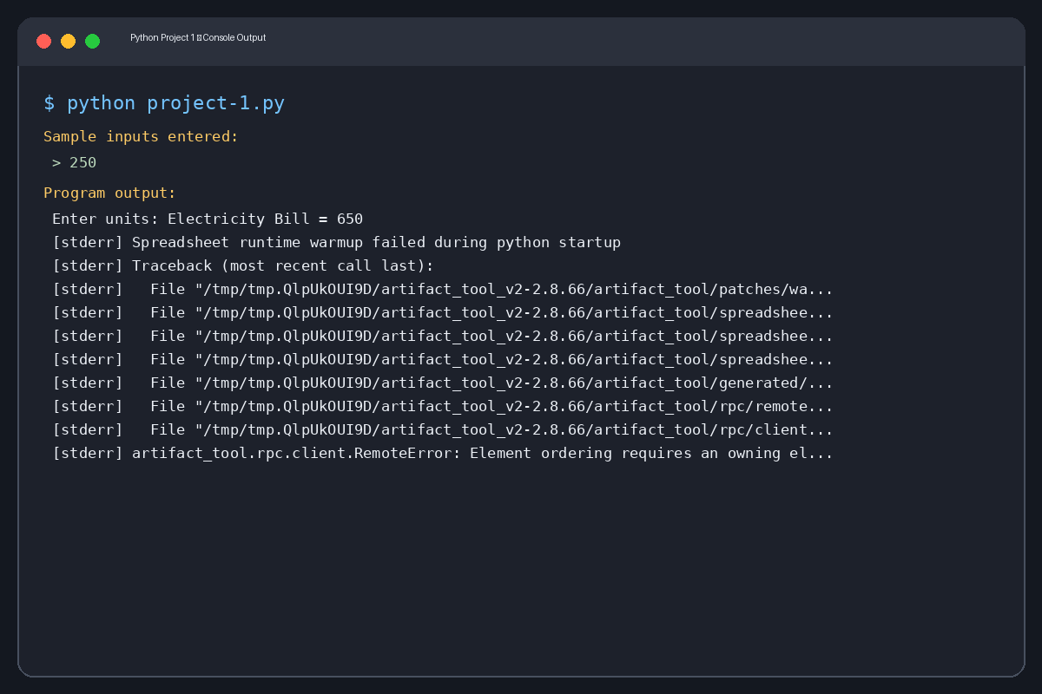
Sample input values: 250

Captured console output (text)
Enter units: Electricity Bill = 650
Errors:
Spreadsheet runtime warmup failed during python startup
Traceback (most recent call last):
File "/tmp/tmp.QlpUkOUI9D/artifact_tool_v2-2.8.66/artifact_tool/patches/warm_spreadsheet_runtime_on_startup.py", line 26, in warm_spreadsheet_runtime_on_startup
File "/tmp/tmp.QlpUkOUI9D/artifact_tool_v2-2.8.66/artifact_tool/spreadsheet_warmup.py", line 785, in warm_spreadsheet_runtime
File "/tmp/tmp.QlpUkOUI9D/artifact_tool_v2-2.8.66/artifact_tool/spreadsheet_warmup.py", line 718, in _warm_feature_flows
File "/tmp/tmp.QlpUkOUI9D/artifact_tool_v2-2.8.66/artifact_tool/spreadsheet_warmup.py", line 509, in _warm_drawing_and_image_flows
File "/tmp/tmp.QlpUkOUI9D/artifact_tool_v2-2.8.66/artifact_tool/generated/interface/models.py", line 32861, in bring_to_front
File "/tmp/tmp.QlpUkOUI9D/artifact_tool_v2-2.8.66/artifact_tool/rpc/remote.py", line 764, in __call__
File "/tmp/tmp.QlpUkOUI9D/artifact_tool_v2-2.8.66/artifact_tool/rpc/client.py", line 175, in call
artifact_tool.rpc.client.RemoteError: Element ordering requires an owning element collection.

Project 2: Employee Payroll
Source file: project-2(1).py
Execution status: Return code 0. Any error text is shown in the output image.
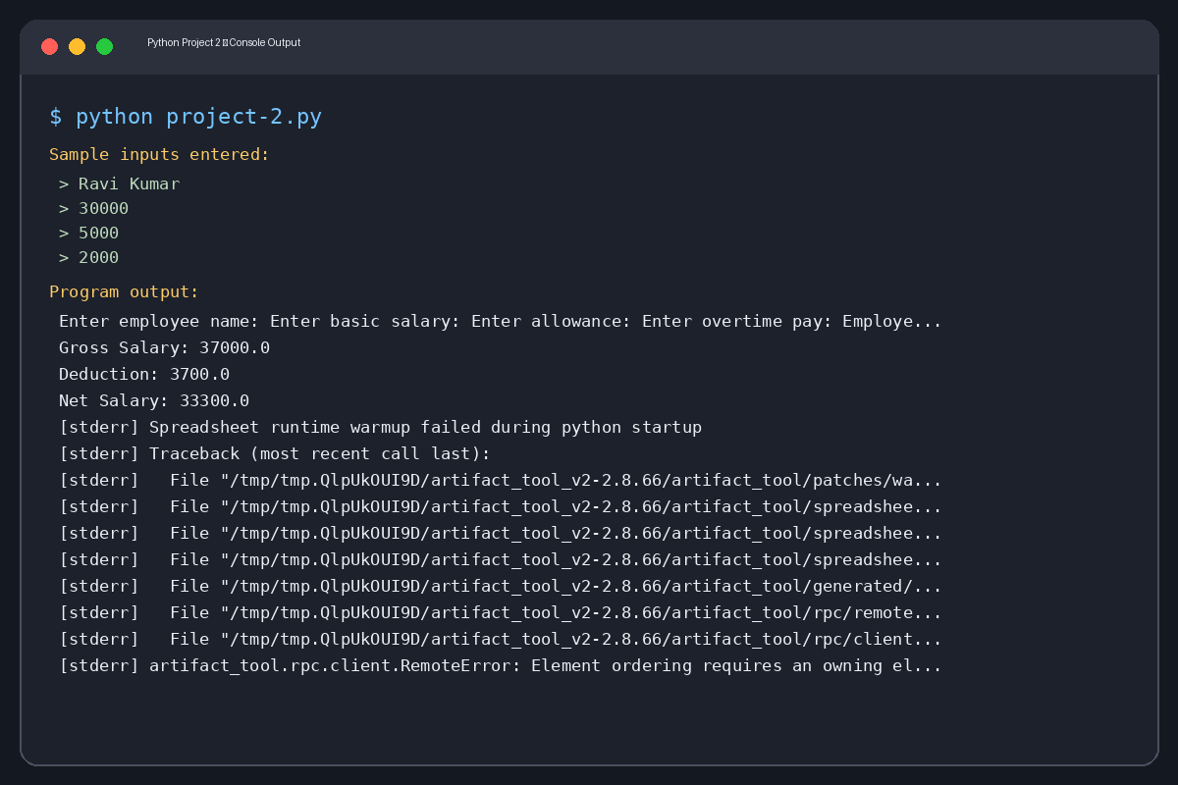
Sample input values: Ravi Kumar, 30000, 5000, 2000

Captured console output (text)
Enter employee name: Enter basic salary: Enter allowance: Enter overtime pay: Employee: Ravi Kumar
Gross Salary: 37000.0
Deduction: 3700.0
Net Salary: 33300.0
Errors:
Spreadsheet runtime warmup failed during python startup
Traceback (most recent call last):
File "/tmp/tmp.QlpUkOUI9D/artifact_tool_v2-2.8.66/artifact_tool/patches/warm_spreadsheet_runtime_on_startup.py", line 26, in warm_spreadsheet_runtime_on_startup
File "/tmp/tmp.QlpUkOUI9D/artifact_tool_v2-2.8.66/artifact_tool/spreadsheet_warmup.py", line 785, in warm_spreadsheet_runtime
File "/tmp/tmp.QlpUkOUI9D/artifact_tool_v2-2.8.66/artifact_tool/spreadsheet_warmup.py", line 718, in _warm_feature_flows
File "/tmp/tmp.QlpUkOUI9D/artifact_tool_v2-2.8.66/artifact_tool/spreadsheet_warmup.py", line 509, in _warm_drawing_and_image_flows
File "/tmp/tmp.QlpUkOUI9D/artifact_tool_v2-2.8.66/artifact_tool/generated/interface/models.py", line 32861, in bring_to_front
File "/tmp/tmp.QlpUkOUI9D/artifact_tool_v2-2.8.66/artifact_tool/rpc/remote.py", line 764, in __call__
File "/tmp/tmp.QlpUkOUI9D/artifact_tool_v2-2.8.66/artifact_tool/rpc/client.py", line 175, in call
artifact_tool.rpc.client.RemoteError: Element ordering requires an owning element collection.

Project 3: Retail Billing
Source file: project-3(1).py
Execution status: Return code 0. Any error text is shown in the output image.
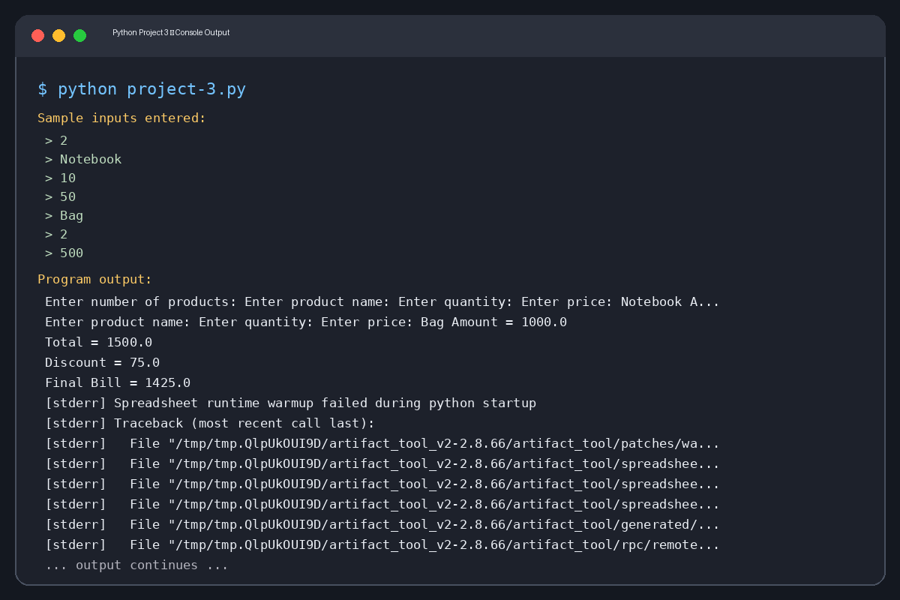
Sample input values: 2, Notebook, 10, 50, Bag, 2, 500

Captured console output (text)
Enter number of products: Enter product name: Enter quantity: Enter price: Notebook Amount = 500.0
Enter product name: Enter quantity: Enter price: Bag Amount = 1000.0
Total = 1500.0
Discount = 75.0
Final Bill = 1425.0
Errors:
Spreadsheet runtime warmup failed during python startup
Traceback (most recent call last):
File "/tmp/tmp.QlpUkOUI9D/artifact_tool_v2-2.8.66/artifact_tool/patches/warm_spreadsheet_runtime_on_startup.py", line 26, in warm_spreadsheet_runtime_on_startup
File "/tmp/tmp.QlpUkOUI9D/artifact_tool_v2-2.8.66/artifact_tool/spreadsheet_warmup.py", line 785, in warm_spreadsheet_runtime
File "/tmp/tmp.QlpUkOUI9D/artifact_tool_v2-2.8.66/artifact_tool/spreadsheet_warmup.py", line 718, in _warm_feature_flows
File "/tmp/tmp.QlpUkOUI9D/artifact_tool_v2-2.8.66/artifact_tool/spreadsheet_warmup.py", line 509, in _warm_drawing_and_image_flows
File "/tmp/tmp.QlpUkOUI9D/artifact_tool_v2-2.8.66/artifact_tool/generated/interface/models.py", line 32861, in bring_to_front
File "/tmp/tmp.QlpUkOUI9D/artifact_tool_v2-2.8.66/artifact_tool/rpc/remote.py", line 764, in __call__
File "/tmp/tmp.QlpUkOUI9D/artifact_tool_v2-2.8.66/artifact_tool/rpc/client.py", line 175, in call
artifact_tool.rpc.client.RemoteError: Element ordering requires an owning element collection.

Project 4: Campus Event Financial Planning
Source file: project-4(1).py
Execution status: Return code 0. Any error text is shown in the output image.
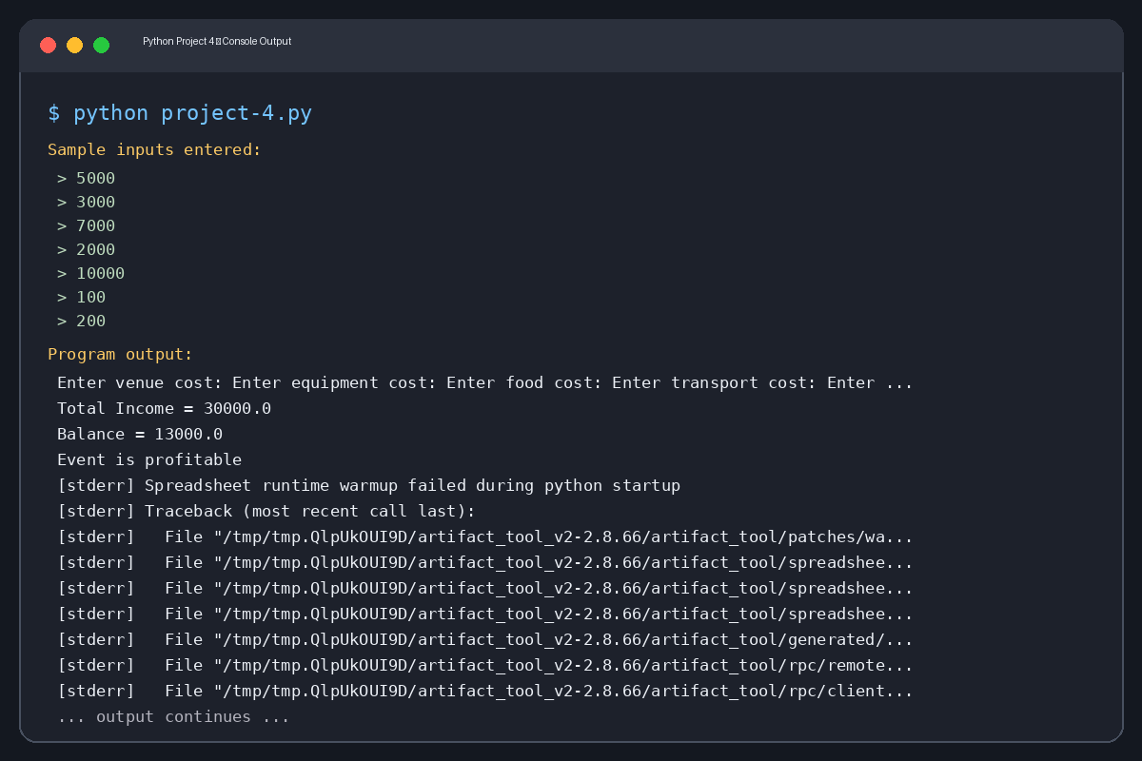
Sample input values: 5000, 3000, 7000, 2000, 10000, 100, 200

Captured console output (text)
Enter venue cost: Enter equipment cost: Enter food cost: Enter transport cost: Enter sponsorship: Enter participants: Enter registration fee: Total Cost = 17000.0
Total Income = 30000.0
Balance = 13000.0
Event is profitable
Errors:
Spreadsheet runtime warmup failed during python startup
Traceback (most recent call last):
File "/tmp/tmp.QlpUkOUI9D/artifact_tool_v2-2.8.66/artifact_tool/patches/warm_spreadsheet_runtime_on_startup.py", line 26, in warm_spreadsheet_runtime_on_startup
File "/tmp/tmp.QlpUkOUI9D/artifact_tool_v2-2.8.66/artifact_tool/spreadsheet_warmup.py", line 785, in warm_spreadsheet_runtime
File "/tmp/tmp.QlpUkOUI9D/artifact_tool_v2-2.8.66/artifact_tool/spreadsheet_warmup.py", line 718, in _warm_feature_flows
File "/tmp/tmp.QlpUkOUI9D/artifact_tool_v2-2.8.66/artifact_tool/spreadsheet_warmup.py", line 509, in _warm_drawing_and_image_flows
File "/tmp/tmp.QlpUkOUI9D/artifact_tool_v2-2.8.66/artifact_tool/generated/interface/models.py", line 32861, in bring_to_front
File "/tmp/tmp.QlpUkOUI9D/artifact_tool_v2-2.8.66/artifact_tool/rpc/remote.py", line 764, in __call__
File "/tmp/tmp.QlpUkOUI9D/artifact_tool_v2-2.8.66/artifact_tool/rpc/client.py", line 175, in call
artifact_tool.rpc.client.RemoteError: Element ordering requires an owning element collection.

Project 5: Examination Result
Source file: project-5(1).py
Execution status: Return code 0. Any error text is shown in the output image.
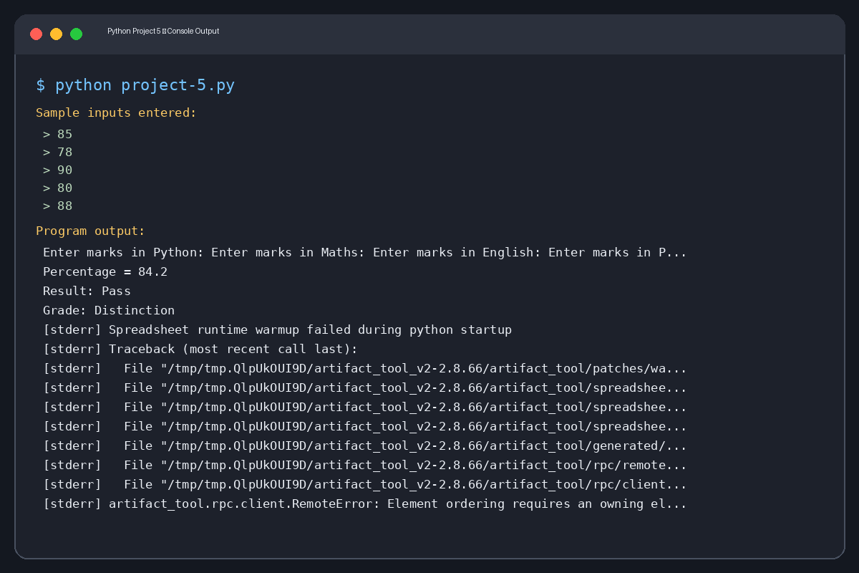
Sample input values: 85, 78, 90, 80, 88

Captured console output (text)
Enter marks in Python: Enter marks in Maths: Enter marks in English: Enter marks in Physics: Enter marks in Chemistry: Total Marks = 421
Percentage = 84.2
Result: Pass
Grade: Distinction
Errors:
Spreadsheet runtime warmup failed during python startup
Traceback (most recent call last):
File "/tmp/tmp.QlpUkOUI9D/artifact_tool_v2-2.8.66/artifact_tool/patches/warm_spreadsheet_runtime_on_startup.py", line 26, in warm_spreadsheet_runtime_on_startup
File "/tmp/tmp.QlpUkOUI9D/artifact_tool_v2-2.8.66/artifact_tool/spreadsheet_warmup.py", line 785, in warm_spreadsheet_runtime
File "/tmp/tmp.QlpUkOUI9D/artifact_tool_v2-2.8.66/artifact_tool/spreadsheet_warmup.py", line 718, in _warm_feature_flows
File "/tmp/tmp.QlpUkOUI9D/artifact_tool_v2-2.8.66/artifact_tool/spreadsheet_warmup.py", line 509, in _warm_drawing_and_image_flows
File "/tmp/tmp.QlpUkOUI9D/artifact_tool_v2-2.8.66/artifact_tool/generated/interface/models.py", line 32861, in bring_to_front
File "/tmp/tmp.QlpUkOUI9D/artifact_tool_v2-2.8.66/artifact_tool/rpc/remote.py", line 764, in __call__
File "/tmp/tmp.QlpUkOUI9D/artifact_tool_v2-2.8.66/artifact_tool/rpc/client.py", line 175, in call
artifact_tool.rpc.client.RemoteError: Element ordering requires an owning element collection.

Project 6: ATM Transaction Simulation
Source file: project-6(1).py
Execution status: Return code 0. Any error text is shown in the output image.
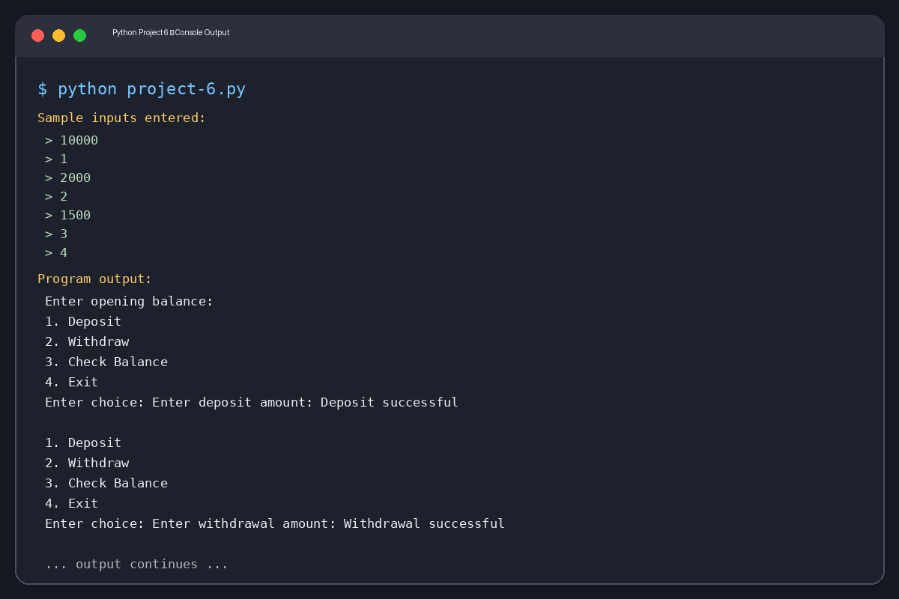
Sample input values: 10000, 1, 2000, 2, 1500, 3, 4

Captured console output (text)
Enter opening balance:
1. Deposit
2. Withdraw
3. Check Balance
4. Exit
Enter choice: Enter deposit amount: Deposit successful
1. Deposit
2. Withdraw
3. Check Balance
4. Exit
Enter choice: Enter withdrawal amount: Withdrawal successful
1. Deposit
2. Withdraw
3. Check Balance
4. Exit
Enter choice: Balance = 10500.0
1. Deposit
2. Withdraw
3. Check Balance
4. Exit
Enter choice: Thank you
Errors:
Spreadsheet runtime warmup failed during python startup
Traceback (most recent call last):
File "/tmp/tmp.QlpUkOUI9D/artifact_tool_v2-2.8.66/artifact_tool/patches/warm_spreadsheet_runtime_on_startup.py", line 26, in warm_spreadsheet_runtime_on_startup
File "/tmp/tmp.QlpUkOUI9D/artifact_tool_v2-2.8.66/artifact_tool/spreadsheet_warmup.py", line 785, in warm_spreadsheet_runtime
File "/tmp/tmp.QlpUkOUI9D/artifact_tool_v2-2.8.66/artifact_tool/spreadsheet_warmup.py", line 718, in _warm_feature_flows
File "/tmp/tmp.QlpUkOUI9D/artifact_tool_v2-2.8.66/artifact_tool/spreadsheet_warmup.py", line 509, in _warm_drawing_and_image_flows
File "/tmp/tmp.QlpUkOUI9D/artifact_tool_v2-2.8.66/artifact_tool/generated/interface/models.py", line 32861, in bring_to_front
File "/tmp/tmp.QlpUkOUI9D/artifact_tool_v2-2.8.66/artifact_tool/rpc/remote.py", line 764, in __call__
File "/tmp/tmp.QlpUkOUI9D/artifact_tool_v2-2.8.66/artifact_tool/rpc/client.py", line 175, in call
artifact_tool.rpc.client.RemoteError: Element ordering requires an owning element collection.

Project 7: Student Performance Analysis
Source file: project-7(1).py
Execution status: Return code 0. Any error text is shown in the output image.
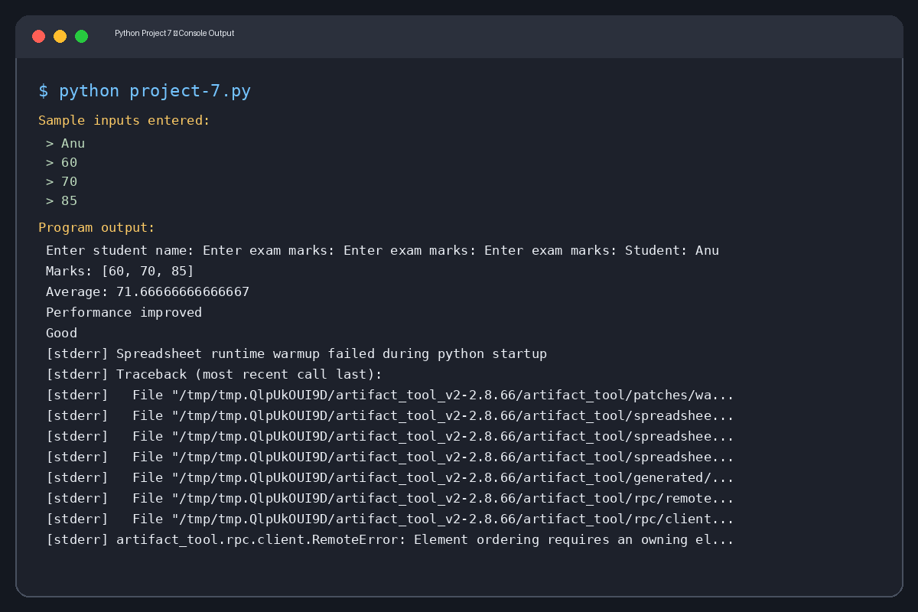
Sample input values: Anu, 60, 70, 85

Captured console output (text)
Enter student name: Enter exam marks: Enter exam marks: Enter exam marks: Student: Anu
Marks: [60, 70, 85]
Average: 71.66666666666667
Performance improved
Good
Errors:
Spreadsheet runtime warmup failed during python startup
Traceback (most recent call last):
File "/tmp/tmp.QlpUkOUI9D/artifact_tool_v2-2.8.66/artifact_tool/patches/warm_spreadsheet_runtime_on_startup.py", line 26, in warm_spreadsheet_runtime_on_startup
File "/tmp/tmp.QlpUkOUI9D/artifact_tool_v2-2.8.66/artifact_tool/spreadsheet_warmup.py", line 785, in warm_spreadsheet_runtime
File "/tmp/tmp.QlpUkOUI9D/artifact_tool_v2-2.8.66/artifact_tool/spreadsheet_warmup.py", line 718, in _warm_feature_flows
File "/tmp/tmp.QlpUkOUI9D/artifact_tool_v2-2.8.66/artifact_tool/spreadsheet_warmup.py", line 509, in _warm_drawing_and_image_flows
File "/tmp/tmp.QlpUkOUI9D/artifact_tool_v2-2.8.66/artifact_tool/generated/interface/models.py", line 32861, in bring_to_front
File "/tmp/tmp.QlpUkOUI9D/artifact_tool_v2-2.8.66/artifact_tool/rpc/remote.py", line 764, in __call__
File "/tmp/tmp.QlpUkOUI9D/artifact_tool_v2-2.8.66/artifact_tool/rpc/client.py", line 175, in call
artifact_tool.rpc.client.RemoteError: Element ordering requires an owning element collection.

Project 8: Fuel Consumption and Route Comparison
Source file: project-8(1).py
Execution status: Return code 0. Any error text is shown in the output image.
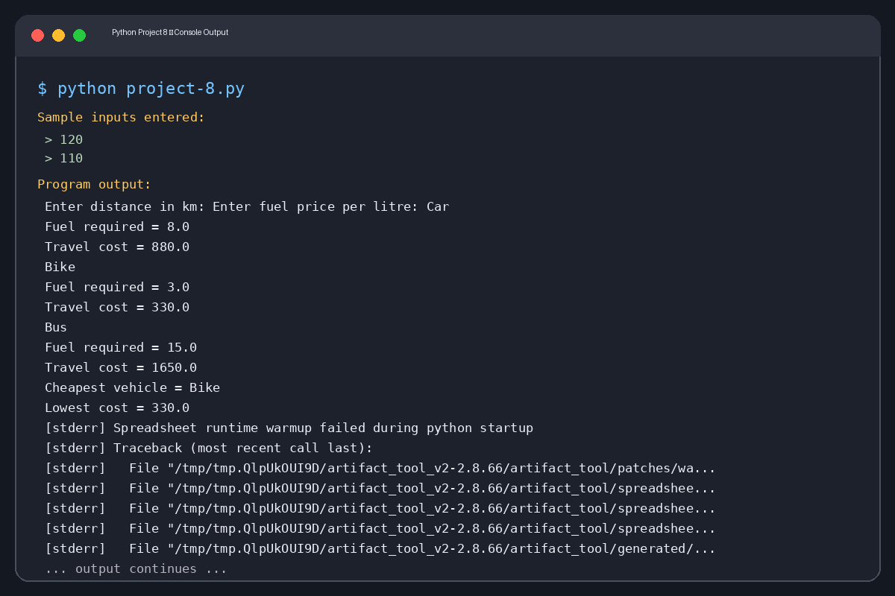
Sample input values: 120, 110

Captured console output (text)
Enter distance in km: Enter fuel price per litre: Car
Fuel required = 8.0
Travel cost = 880.0
Bike
Fuel required = 3.0
Travel cost = 330.0
Bus
Fuel required = 15.0
Travel cost = 1650.0
Cheapest vehicle = Bike
Lowest cost = 330.0
Errors:
Spreadsheet runtime warmup failed during python startup
Traceback (most recent call last):
File "/tmp/tmp.QlpUkOUI9D/artifact_tool_v2-2.8.66/artifact_tool/patches/warm_spreadsheet_runtime_on_startup.py", line 26, in warm_spreadsheet_runtime_on_startup
File "/tmp/tmp.QlpUkOUI9D/artifact_tool_v2-2.8.66/artifact_tool/spreadsheet_warmup.py", line 785, in warm_spreadsheet_runtime
File "/tmp/tmp.QlpUkOUI9D/artifact_tool_v2-2.8.66/artifact_tool/spreadsheet_warmup.py", line 718, in _warm_feature_flows
File "/tmp/tmp.QlpUkOUI9D/artifact_tool_v2-2.8.66/artifact_tool/spreadsheet_warmup.py", line 509, in _warm_drawing_and_image_flows
File "/tmp/tmp.QlpUkOUI9D/artifact_tool_v2-2.8.66/artifact_tool/generated/interface/models.py", line 32861, in bring_to_front
File "/tmp/tmp.QlpUkOUI9D/artifact_tool_v2-2.8.66/artifact_tool/rpc/remote.py", line 764, in __call__
File "/tmp/tmp.QlpUkOUI9D/artifact_tool_v2-2.8.66/artifact_tool/rpc/client.py", line 175, in call
artifact_tool.rpc.client.RemoteError: Element ordering requires an owning element collection.

Project 9: Password Validation
Source file: project-9(1).py
Execution status: Return code 0. Any error text is shown in the output image.
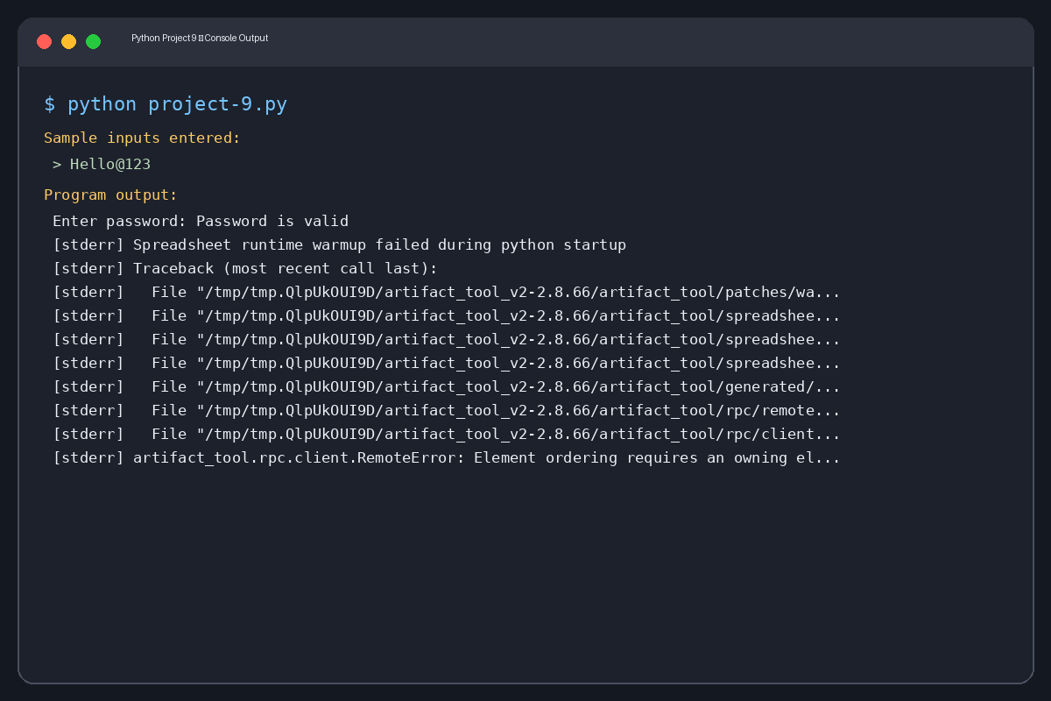
Sample input values: Hello@123

Captured console output (text)
Enter password: Password is valid
Errors:
Spreadsheet runtime warmup failed during python startup
Traceback (most recent call last):
File "/tmp/tmp.QlpUkOUI9D/artifact_tool_v2-2.8.66/artifact_tool/patches/warm_spreadsheet_runtime_on_startup.py", line 26, in warm_spreadsheet_runtime_on_startup
File "/tmp/tmp.QlpUkOUI9D/artifact_tool_v2-2.8.66/artifact_tool/spreadsheet_warmup.py", line 785, in warm_spreadsheet_runtime
File "/tmp/tmp.QlpUkOUI9D/artifact_tool_v2-2.8.66/artifact_tool/spreadsheet_warmup.py", line 718, in _warm_feature_flows
File "/tmp/tmp.QlpUkOUI9D/artifact_tool_v2-2.8.66/artifact_tool/spreadsheet_warmup.py", line 509, in _warm_drawing_and_image_flows
File "/tmp/tmp.QlpUkOUI9D/artifact_tool_v2-2.8.66/artifact_tool/generated/interface/models.py", line 32861, in bring_to_front
File "/tmp/tmp.QlpUkOUI9D/artifact_tool_v2-2.8.66/artifact_tool/rpc/remote.py", line 764, in __call__
File "/tmp/tmp.QlpUkOUI9D/artifact_tool_v2-2.8.66/artifact_tool/rpc/client.py", line 175, in call
artifact_tool.rpc.client.RemoteError: Element ordering requires an owning element collection.

Project 10: Food Waste Monitoring
Source file: project-10(1).py
Execution status: Return code 0. Any error text is shown in the output image.
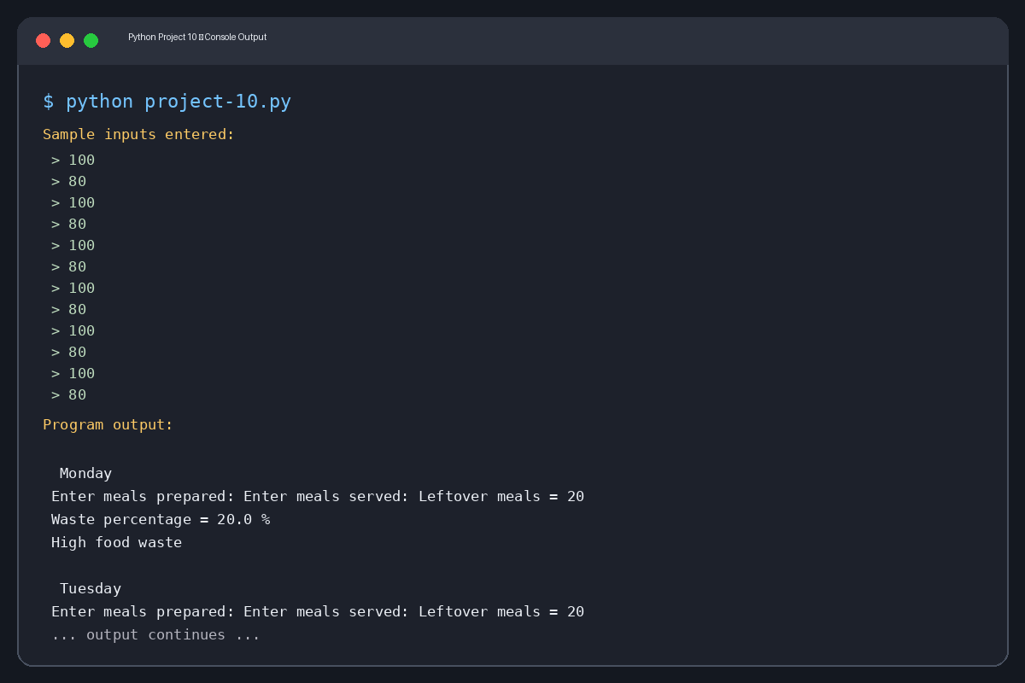
Sample input values: 100, 80, 100, 80, 100, 80, 100, 80 ...

Captured console output (text)
Monday
Enter meals prepared: Enter meals served: Leftover meals = 20
Waste percentage = 20.0 %
High food waste
Tuesday
Enter meals prepared: Enter meals served: Leftover meals = 20
Waste percentage = 20.0 %
High food waste
Wednesday
Enter meals prepared: Enter meals served: Leftover meals = 20
Waste percentage = 20.0 %
High food waste
Thursday
Enter meals prepared: Enter meals served: Leftover meals = 20
Waste percentage = 20.0 %
High food waste
Friday
Enter meals prepared: Enter meals served: Leftover meals = 20
Waste percentage = 20.0 %
High food waste
Saturday
Enter meals prepared: Enter meals served: Leftover meals = 20
Waste percentage = 20.0 %
High food waste
Sunday
Enter meals prepared: Enter meals served: Leftover meals = 20
Waste percentage = 20.0 %
High food waste
Weekly Summary
Total Prepared = 700
Total Served = 560
Total Leftover = 140
Errors:
Spreadsheet runtime warmup failed during python startup
Traceback (most recent call last):
File "/tmp/tmp.QlpUkOUI9D/artifact_tool_v2-2.8.66/artifact_tool/patches/warm_spreadsheet_runtime_on_startup.py", line 26, in warm_spreadsheet_runtime_on_startup
File "/tmp/tmp.QlpUkOUI9D/artifact_tool_v2-2.8.66/artifact_tool/spreadsheet_warmup.py", line 785, in warm_spreadsheet_runtime
File "/tmp/tmp.QlpUkOUI9D/artifact_tool_v2-2.8.66/artifact_tool/spreadsheet_warmup.py", line 718, in _warm_feature_flows
File "/tmp/tmp.QlpUkOUI9D/artifact_tool_v2-2.8.66/artifact_tool/spreadsheet_warmup.py", line 509, in _warm_drawing_and_image_flows
File "/tmp/tmp.QlpUkOUI9D/artifact_tool_v2-2.8.66/artifact_tool/generated/interface/models.py", line 32861, in bring_to_front
File "/tmp/tmp.QlpUkOUI9D/artifact_tool_v2-2.8.66/artifact_tool/rpc/remote.py", line 764, in __call__
File "/tmp/tmp.QlpUkOUI9D/artifact_tool_v2-2.8.66/artifact_tool/rpc/client.py", line 175, in call
artifact_tool.rpc.client.RemoteError: Element ordering requires an owning element collection.

